Olist E-Commerce Analysis
Business Understanding, Data Model & Dashboard Plan
Graduation Project — Brazilian E-Commerce Dataset (Olist)
Created by : Abdelhadi Mohamed Ali
This document covers company background, verified data understanding, table relationships, key diagnostic findings from the real data, and the complete dashboard structure (KPIs + charts per page).

1. Company Background — Olist
Olist is a Brazilian e-commerce startup, founded in 2015, that operates as a marketplace integrator (B2B model). It connects small and medium-sized merchants across Brazil to major marketplaces — Mercado Livre, Amazon, and others — through a single contract and dashboard, handling listings, logistics and payments on their behalf.
The dataset used in this project is the anonymized order data generated through Olist's systems between 2016 and 2018 (~100k orders), covering order status, price, payment, freight performance, customer location, product attributes, and customer reviews.

2. Data Understanding
Nine tables, verified directly from the CSV files (row counts, primary keys, and duplicate checks — not assumed from documentation):
Table | Rows | Primary key | Note
customers | 99,441 | customer_id | customer_unique_id identifies the real person
orders | 99,441 | order_id | Core fact table
order_items | 112,650 | order_id + order_item_id | One row per item in an order
order_payments | 103,886 | order_id + payment_sequential | One row per payment/installment
order_reviews | 99,224 | review_id + order_id | review_id alone is not unique
products | 32,951 | product_id | 610 rows missing category data
sellers | 3,095 | seller_id | —
geolocation | 1,000,163 | None | 261,831 duplicate rows — needs dedup
category_translation | 71 | product_category_name | Portuguese → English lookup
Two fields that were requested but do not exist in this dataset: customer gender, and product cost/COGS (so true "profit" cannot be computed — only revenue). Both are flagged wherever they would otherwise appear below.

Data Dictionary

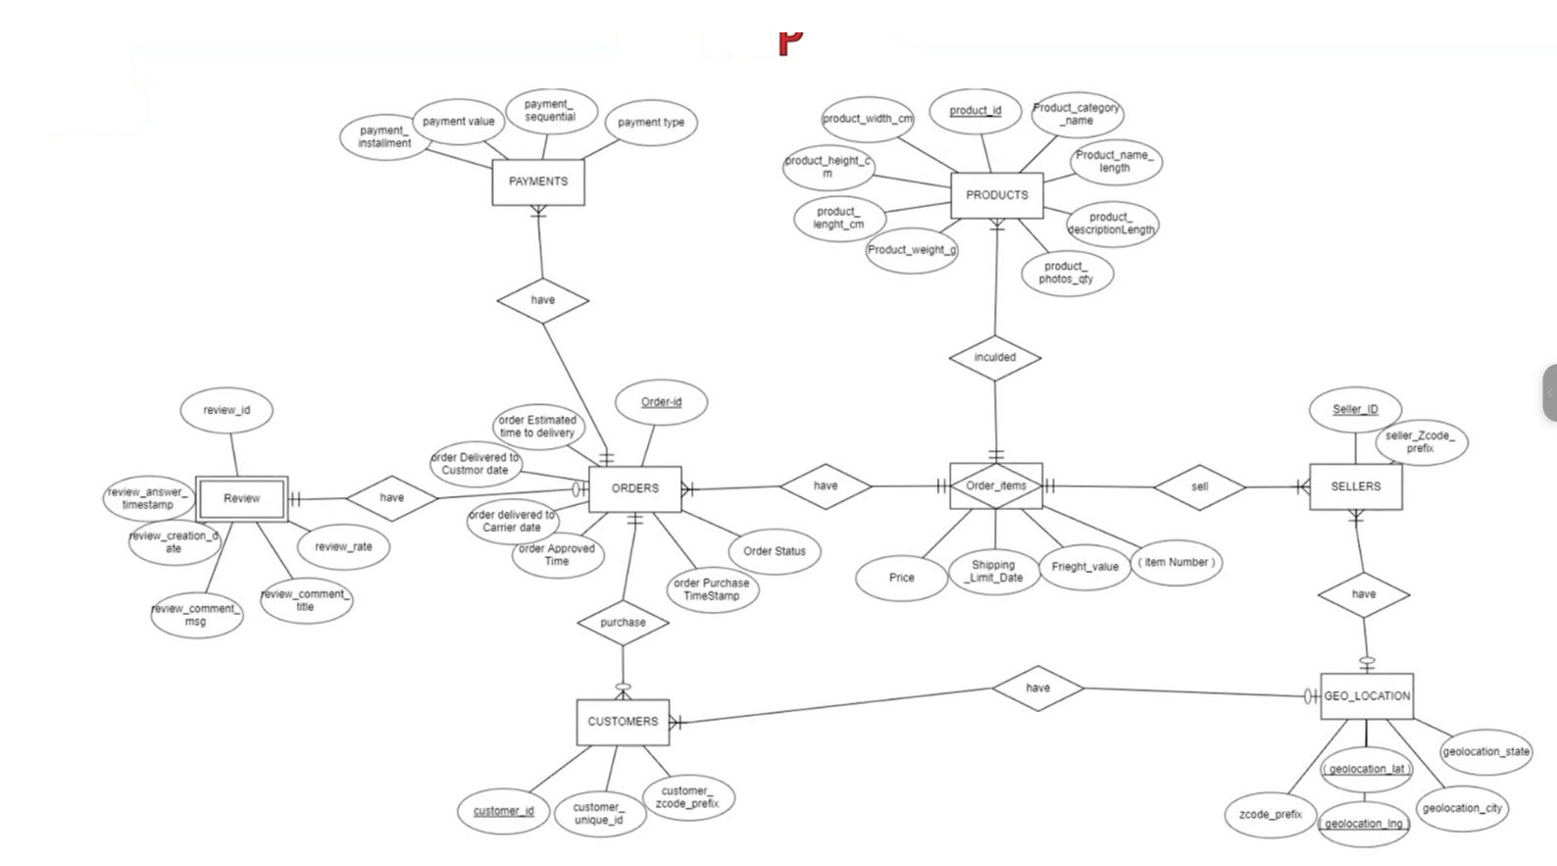
3. Table Relationships

geolocation has no reliable primary key and links to customers/sellers only through zip_code_prefix (a lookup, not an enforced unique key).
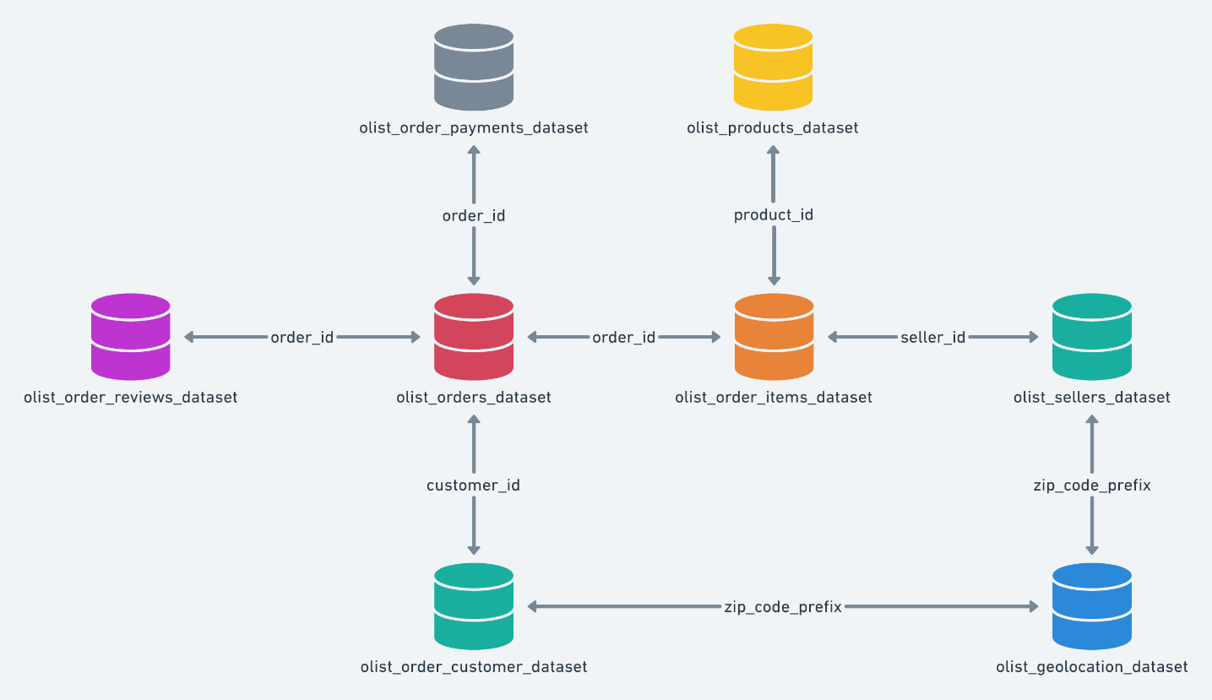

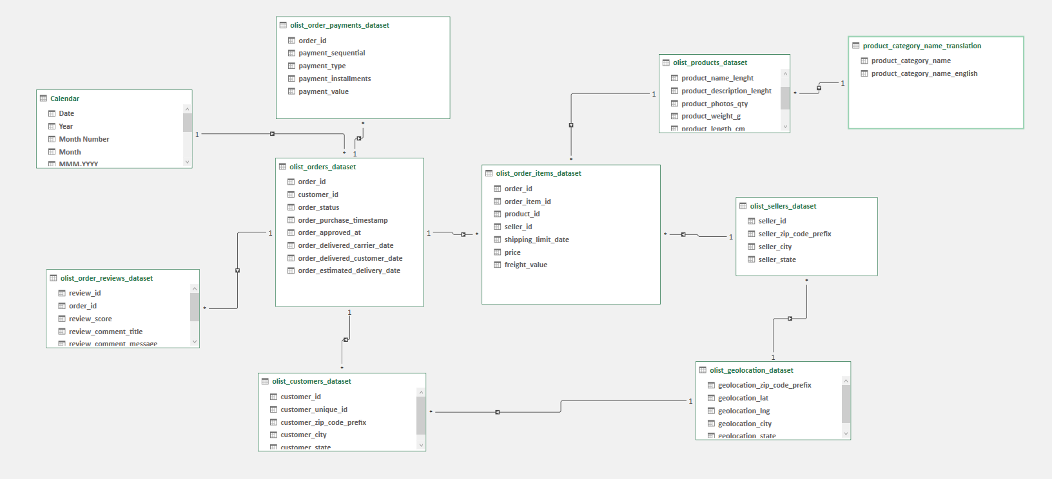
4. Exploratory Data Analysis — Data Quality Findings
Every item below was checked directly against the actual CSV files. Grouped by what it means for the project: what Member 2 (Cleaning) needs to handle, and what needs a decision before analysis starts.
4.1 Good news — referential integrity is clean
- Zero orphan records anywhere: every order_item, payment, and review correctly points to a real order; every order points to a real customer; every order_item points to a real product and a real seller. No cleaning needed on foreign keys themselves.
4.2 Incomplete date range — affects trend charts
Cleaning note
The data spans Sep 2016 to Oct 2018, but the edges are nearly empty: Sep 2016 = 4 orders, Nov 2016 = 0, Dec 2016 = 1, Sep 2018 = 16, Oct 2018 = 4 (vs. 6,000+/month in mid-2018). If these partial months are left in a monthly revenue trend chart, they'll show as fake collapses at the start and end. Recommendation: exclude or visually flag Sep–Dec 2016 and Sep–Oct 2018 in any time trend, or filter the dashboard's default date range to Jan 2017 – Aug 2018.

4.3 Order status — scoping decision needed
Status | Count
delivered | 96,478
shipped | 1,107
canceled | 625
unavailable | 609
invoiced | 314
processing | 301
created | 5
approved | 2
Decision: revenue, delivery-time, and review analysis should use "delivered" only (what this project already does) — the other statuses either never shipped or are mid-flow with no outcome yet. Cancellation-rate analysis should use all statuses, not just delivered.
4.4 Orders with no linked items/payments/reviews — expected, not broken
- 775 orders have zero order_items — almost all are "unavailable" (603) or "canceled" (164) orders that never got fulfilled. Expected behavior, not a data error — exclude from item-level analysis but keep for cancellation analysis.
- 1 delivered order has no payment record at all — a genuine edge case (1 row), safe to drop.
- 768 orders have no review — normal opt-out behavior (~0.8% of orders). Cleaning rule: do not impute a review score for these; simply exclude them from review-based metrics rather than assuming a neutral/average score.
4.6 Price, freight & weight outliers
- 383 items (0.3%) have freight_value = 0 — likely free-shipping promotions; worth a quick spot check but not necessarily an error.
- 4,124 items (3.7%) have freight cost higher than the product's own price — a distinct "low-value, expensive-to-ship" segment worth its own chart on the Logistics page,
- 123 items are priced above R$2,000 (max R$6,735) — legitimate premium products (electronics/appliances), but box plots and bar charts should use a capped/log scale so these don't visually flatten the rest of the distribution.
- Product weight has one extreme value (40.4 kg) and otherwise looks reasonable (median 700g) — worth a single spot-check, not a systemic issue.
4.7 Category name gaps — will break category charts if not fixed
Cleaning note
Two category names used in the products table (pc_gamer, portateis_cozinha_e_preparadores_de_alimentos — 13 products total) do not exist in the category_translation lookup table. Joining products to category_translation as-is will silently turn these 13 products' category into blank/NaN in every category chart. Fix: add the two missing translations manually before building the model. Separately, 610 products have no category name at all — bucket these as "Unknown/Other" rather than dropping them, since they still carry real revenue.

4.8 Multi-seller orders — a modeling decision, not a bug
- 1,278 orders (1.3%) include items from more than one seller in the same order. Since review_score and delivery date are recorded at the order level, not per seller, a single review can't be cleanly attributed to just one seller in these cases. Decision needed: either exclude multi-seller orders from seller-level review/delay scoring, or attribute the whole order's outcome to all involved sellers (with a caveat in the documentation).
4.9 Payment inconsistencies
- 249 orders (0.25%) have a payment total that differs from their item+freight total by more than R$1
- have payment_installments = 0 with payment_type = credit_card — logically odd (should be at least 1)
4.10 Free-text city names need normalization
- customer_city has 4,119 unique raw text values — almost certainly includes multiple spellings/casings of the same city (a known characteristic of this dataset). Left as-is, city-level charts will fragment the same real city into several rows. Recommendation: normalize casing/accents as a cleaning step before any city-level aggregation.
4.11 Reviews — limited text coverage
- Only 41% of reviews (40,977 of 99,224) have a written comment; the rest are score-only. If any sentiment/text analysis is planned on top of this project, be aware it would only ever cover a minority of orders — the score-based analysis (already the core of this plan) remains the reliable path.

5. Feature Engineering & Segmentation Plan
Columns that don't exist yet in the raw tables but are needed for the analysis above — this is what Member 3 (Data Modeling) needs to build.
5.1 New computed columns needed
New column | Built from | Used for
delivery_delay_days | delivered_customer_date − estimated_delivery_date | Late delivery / logistics analysis
actual_delivery_days | delivered_customer_date − purchase_timestamp | Delivery speed trend
is_late (flag) | delivery_delay_days > 0 | On-time vs. late KPI
order_year / order_month / order_quarter | order_purchase_timestamp | Revenue trend charts
order_day_of_week / order_hour | order_purchase_timestamp | Peak demand analysis
item_revenue | price + freight_value | All revenue KPIs
is_multi_seller_order (flag) | count of distinct seller_id per order_id | Seller attribution logic
price_bucket | price split into cheap/medium/expensive tiers | Product price-vs-review analysis
5.2 Customer segmentation — needed for Customer Analysis page
Classic RFM (Recency/Frequency/Monetary) scoring is less useful here since 96.9% of customers ordered exactly once — recency scoring on a single data point isn't meaningful for most of the base. A simpler frequency-based tier fits this data better:
Segment | Rule | Share of customers
One-time buyer | Exactly 1 order | 96.9%
Repeat buyer | 2–3 orders | ~3.0%
VIP / Power buyer | 4+ orders | ~0.1% (max observed: 17 orders)
This segment becomes a filter across the whole dashboard (e.g. "does the VIP segment have a different average review score or AOV than one-time buyers?").
5.3 Seller performance classification — needed for Seller/Logistics pages
Seller size is extremely long-tailed: median seller has 7 orders / R$846 revenue, but the top seller alone has 1,819 orders / R$226,988 revenue. Equal-width buckets would put almost every seller in one bucket — use revenue percentile instead, crossed with delay rate:
Tier | Rule (suggested) | Meaning
Star Seller | Top 10% by revenue AND late_rate below average | Scale — reliable and high-volume
Risk Seller | Top 10% by revenue BUT late_rate above average | High-volume but hurting satisfaction — priority to fix
Standard Seller | Middle 80% by revenue | Bulk of the marketplace
New / Low-volume | 1 order only (535 sellers — 18% of all sellers) | Not enough data yet to score fairly
125 of the 3,095 registered sellers have zero delivered orders at all — exclude them from performance scoring entirely rather than showing a 0% score.

6. Key Diagnostic Findings (from the real data)
Before designing chart-by-chart, the numbers below were computed directly on the dataset to confirm which relationships are actually real — this is what separates a diagnostic dashboard from a purely descriptive one.
Finding 1 — Delivery delay is the dominant driver of dissatisfaction, not price
Correlation between total delivery time and review score: -0.33. Correlation between delay vs. estimated date and review score: -0.27. Orders delivered on time average 4.29★, late orders average only 2.27★ — a 2-star gap. By contrast, price and freight value show almost no correlation with review score (-0.005 and -0.03) — pricing is not what drives complaints.

Finding 2 — Late deliveries are rare but severe
Only 6.66% of delivered orders arrive late, but when they do, the average delay is 10.5 days and satisfaction collapses. This is a small, high-impact segment worth a dedicated recovery process (proactive communication, compensation) rather than a broad logistics overhaul.

Finding 3 — Revenue is geographically concentrated
The top 5 states (SP, RJ, MG, RS, PR) generate 73.2% of total revenue; São Paulo alone accounts for about 37%. This is a concentration risk worth flagging to leadership.

Finding 4 — Repeat purchase rate is very low
Only 3.1% of unique customers place more than one order. The business is overwhelmingly driven by first-time buyers, which points to a retention opportunity rather than pure acquisition.

Finding 5 — Voucher payments cancel far more often
Cancellation rate by payment type: voucher 3.21%, credit card 0.57%, boleto 0.48%, debit card 0.46%. Voucher-based orders are roughly 6x more likely to be cancelled than any other payment method.

7. Business Questions for Page

Sales & Revenue
- What is the total revenue, and how has it changed over time (monthly/quarterly)?
- Which product categories generate the highest revenue?
- What is the average order value, and how does it vary by category or payment method?
- Do a small number of products/categories drive most of the revenue (80/20 pattern)?

Customers
- How many unique customers are there, and what percentage are repeat customers?
- How much does the average customer spend, and how many orders does each place?
- Which states/cities have the largest and highest-spending customer base?

Products
- Which product categories have the highest sales volume and highest revenue?
- Are product prices distributed reasonably, or are there major outliers?
- Is the catalog dependent on a few "star" categories, or are there many unsold products?

Sellers
- Who are the top-performing sellers by revenue and by order volume?
- Is revenue concentrated among a small number of sellers, or spread evenly across the marketplace?
- Is seller size related to delivery speed or delay rate?

Delivery & Logistics
- What is the average delivery time, and how does actual delivery compare to the estimated date?
- Which regions experience the most delivery delays?
- Which sellers are responsible for the most late deliveries?

Payments
- What are the most frequently used payment methods?
- How does payment method (installments vs. full payment) relate to order value?
- Is there a relationship between payment method and order cancellation?

Customer Experience (Reviews)
- What is the average review score, and how does it trend over time?
- Which categories or sellers receive the lowest review scores?
- Is there a relationship between delivery delay and review score?

8. Dashboard Structure — Page by Page
Each page below lists the KPIs (single numbers) separately from the charts (visual breakdowns), matched to a specific business question and chart type. Diagnostic pages (Operational, Logistics, Reviews) go beyond "what happened" and are built around the findings in section 4.
1. Executive Overview
Descriptive — is the business healthy at a glance?
KPIs
KPI | Definition
Total Revenue | R$ 15.4M (delivered orders only)
Total Orders | 99,441 (96,478 delivered)
Total Customers | 96,096 unique customers
Total Sellers / Products | 3,095 sellers / 32,951 products
Repeat Customer Rate | 3.1%
Late Delivery Rate | 6.66%
Average Review Score | Overall average across all reviews

Charts
Business question | Chart | Type
Is revenue growing? | Revenue trend | Line chart
What is the order funnel status? | Orders by status | Donut chart
Where does revenue come from? | Revenue by state | Filled map

2. Sales Performance
Descriptive — what's driving revenue?
KPIs
KPI | Definition
Total Revenue | Sum of price + freight, delivered orders
Average Order Value (AOV) | Revenue / number of orders
Revenue Growth % | Period-over-period change
Top Category Revenue Share | health_beauty leads at R$1.41M

Charts
Business question | Chart | Type
How has revenue changed over time? | Revenue trend (monthly/quarterly) | Line chart
Which categories generate the most revenue? | Top 10 categories by revenue | Horizontal bar
Which products sell the most? | Top 10 products by revenue/qty | Horizontal bar
How does order value vary by category? | AOV by category | Bar chart
Do a few products drive most revenue? | Pareto analysis (80/20) | Pareto chart
Are sales seasonal by weekday? | Weekday vs weekend orders (77% / 23%) | Bar chart

3. Customer Analysis
Descriptive — who buys, and where?
KPIs
KPI | Definition
Total Customers | 96,096 unique
Repeat Customer Rate | 3.1%
Customer Segment Split | One-time 96.9% / Repeat 3.0% / VIP 0.1%
Top State by Customers | São Paulo (SP)

Charts
Business question | Chart | Type
Who are the top buying customers? | Top customers by spend | Horizontal bar
Which cities/states buy the most? | Customers & orders by state | Map
Are customers new or returning? | One-time vs. repeat vs. VIP (segment 5.2) | Donut chart
How does payment preference vary by customer? | Payment type by customer segment | Stacked bar

4. Operational Analysis
Diagnostic — what drives cancellations and demand timing?
KPIs
KPI | Definition
Overall Cancellation Rate | 0.63% of all orders
Cancellation Rate — Voucher | 3.21% (highest)
Cancellation Rate — Card/Boleto | ~0.5% (lowest)
Peak Order Day | Weekdays carry 77% of orders

Charts
Business question | Chart | Type
Which factors relate to cancellation? | Cancellation rate by payment type | Bar chart
When is demand highest? | Orders by day of week | Bar chart
What time of day do people order? | Orders by hour | Line chart
Are completed orders skewed by payment method? | Completed orders by payment type | Bar chart

5. Logistics Performance
Diagnostic — what causes delays, and what do they cost us?
KPIs
KPI | Definition
On-Time Delivery Rate | 93.34%
Late Delivery Rate | 6.66%
Avg. Delay (late orders only) | 10.5 days
Avg. Total Delivery Time | 12.05 days
Avg. Shipping Cost | Average freight_value

Charts
Business question | Chart | Type
Is delivery speed improving or worsening? | Delivery time trend | Line chart
Is the company meeting its promised dates? | On-time vs. late | Donut chart
Which regions are slowest? | Delivery time by state | Bar chart
Which sellers cause the most delays? | Avg. delay by seller (top 10) | Bar chart
Does shipping cost relate to speed? | Shipping cost vs. delivery time | Scatter plot

6. Reviews & Satisfaction
Diagnostic (centerpiece) — what actually drives the score?
KPIs
KPI | Definition
Average Review Score | Overall mean across all reviews
5-Star Share | % of reviews scoring 5
1–2 Star Share | % of reviews scoring 1 or 2
Correlation: delay vs. score | -0.33 (moderate negative)
Correlation: price vs. score | -0.005 (negligible)

Charts
Business question | Chart | Type
Are customers satisfied overall? | Review score distribution | Column chart
Is satisfaction trending up or down? | Review score over time | Line chart
Does delay explain low scores? | Avg. score: on-time (4.29) vs. late (2.27) | Bar chart
Which categories score worst / best? | Top 10 & bottom 10 categories by score | Horizontal bar
Does price affect satisfaction? | Price vs. review score | Scatter plot (flat trend)

7. Payments Analysis
Descriptive + light diagnostic
KPIs
KPI | Definition
Credit Card Share | 73.9% of payments
Boleto Share | 19.0%
Voucher Share | 5.6%
Avg. Installments | Average number chosen

Charts
Business question | Chart | Type
How do customers prefer to pay? | Payment method distribution | Donut chart
Does payment method affect order value? | AOV by payment type | Bar chart
Does payment method affect cancellation? | Cancellation rate by payment type | Bar chart
Does payment method affect satisfaction? | Review score by payment type | Bar chart

8. Executive Insights & Recommendations
Built from section 4's findings once the analysis is complete — no placeholder numbers.
- Prioritize logistics reliability over pricing: satisfaction is driven by delivery delay (corr -0.33), not price (corr ~0). A pricing-focused improvement plan would miss the actual problem.
- Build a dedicated late-order recovery process: only 6.66% of orders are late, but they average 10.5 days of delay and a 2-star satisfaction drop — a small, fixable segment with outsized impact.
- Watch geographic concentration: 73% of revenue comes from 5 states (37% from São Paulo alone) — a regional disruption would hit revenue disproportionately.
- Investigate retention: only 3.1% of customers are repeat buyers — most growth currently depends on constantly acquiring new customers.
- Review the voucher payment flow: cancellation rate is ~6x higher for vouchers (3.21%) than any other payment method.
ممكن تشوف ده كمان (انا مكملتوش)

